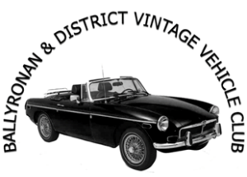

NAME: …………………………………………………………………………………………………………………………………………….
ADDRESS: …………………………………………………………………………………………………………………………………………
POSTCODE: …………………………………………………
PHONE NUMBER: ……………………………………………………………
VEHICLE DETAILS

MAKE: …………………………………………………………………………………………
MODEL: …………………………………………………………………………………….
YEAR: ……………………………………………………………….
REG NO: …………………………………………………………………
The information above will be stored securely to process this Entry. This will not be disclosed to any third parties.
Tick the box to give consent to send you Entry Forms for future events.

Tick to give consent that your Name, Town vehicle details may be used for any pre/post event publicity and on the list of entrants given out at the event.

Declaration: In consideration of this entry being accepted and my being permitted to take part in the above event, I declare that during the whole period of the display and drive my entry will be covered by insurance as required by the relevant law applicable and is valid for an event such as this. I confirm that the driver(s) of any vehicle entered holds or has held and is not disqualified from holding or obtaining a licence to drive a vehicle of the appropriate class. I further agree to abide by regulations governing the event, with the directions given by appointed marshals and with the decision of the Organising Committee on any matter. I confirm the year of first registration of the vehicle entered above is correct.

Signed by Entrant: Date:

This event is run under the authority of the Association of Old Vehicles Clubs in N Ireland Ltd.

