Cars and Coffee

AUTOJUMBLE

Donate, Buy or Sell at our Premier Charity Event in aid of

**The** **Guide Dogs for the Blind Association**

Saturday 12th October 2024 9 am to 4 pm

Ballymacbrennan School Hall, 129A Saintfield Road, Lisburn, BT27 5PG

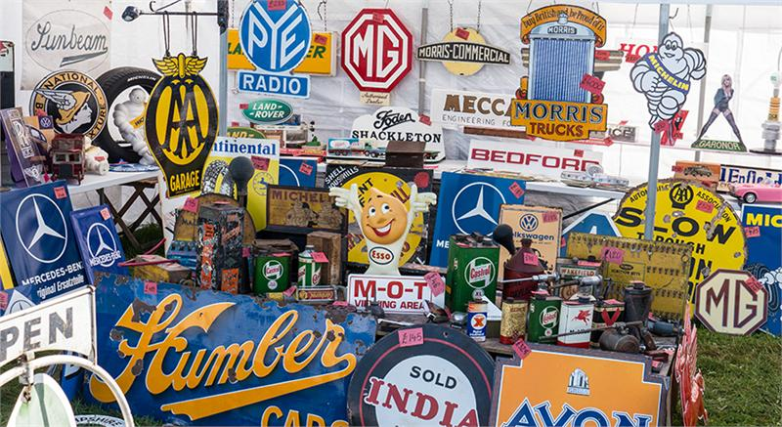

Please donate items such as parts, tools, garage related items, accessories, cleaning materials, books, magazines, wall art, old transport toys, t-shirts, regalia, vintage clothing, bicycles.

Sell your car, motor cycle or other items of value with us on a commission basis.

Free Admission

All Classic Cars Welcome in our Display Area

Tea or Coffee and a Traybake £4.

Organised by the MG Owners’ Club N. I.

For further details please contact Sam on 0775404345